Day 44 – Serving ML Models

Two important concepts in serving ML models are Input Validation and Error Handling.

1. Input Validation
Input Validation is the process of checking whether the data received from the user is correct, complete, and in the expected format before sending it to the ML model.
Think of it as a security guard checking whether a person has a valid ticket before entering a stadium.

Why is Input Validation Important?
Without validation:
- The model may crash.
- Incorrect predictions may be generated.
- Security vulnerabilities can occur.
- Application reliability decreases.

Example
House Price Prediction model expects:
Feature | Type
Area | Integer
Bedrooms | Integer
Bathrooms | Integer

Valid Input:
{
"area": 1500,
"bedrooms": 3,
"bathrooms": 2
}
Invalid Input:
{
"area": "large",
"bedrooms": -2,
"bathrooms": "two"
}

Types of Input Validation

1. Data Type Validation
Checks whether the correct datatype is provided.
Example:
area = 1500 # Valid
area = "large" # Invalid

2. Range Validation
Checks whether values fall within acceptable limits.
Example:
age = 25 # Valid
age = -5 # Invalid
For house prediction:
area > 0
bedrooms > 0

3. Required Field Validation
Ensures all necessary fields are present.
Example:
{
"area": 1500
}
Missing:
bedrooms
bathrooms

4. Format Validation
Checks specific formats.
Examples:
- Email format
- Date format
- Phone number format
abc@gmail.com (correct)
abcgmail.com (wrong)

Input Validation in FastAPI
FastAPI uses Pydantic models for automatic validation.

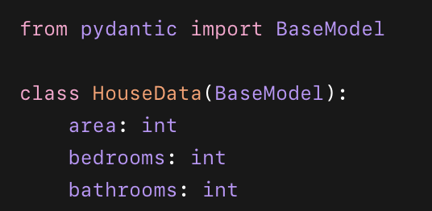
If invalid data is sent, FastAPI automatically returns an error.

2. Error Handling
Error Handling is the process of detecting, managing, and responding to errors without crashing the application.
Instead of showing:
Application Crashed
we provide meaningful messages like:
Invalid input: Area must be greater than 0

Why Error Handling is Important?
- Improves user experience.
- Prevents application crashes.
- Helps debugging.
- Makes APIs more reliable.

Common Errors in ML APIs

1. Invalid Input Error
Example:
{
"area": "big"
}
Response:
{
"error": "Area must be numeric"
}

2. Missing Field Error
Example:
{
"area": 1500
}
Response:
{
"error": "Bedrooms field missing"
}

3. Model Loading Error
Occurs when the saved model file is missing.
Example:
FileNotFoundError
Response:
{
"error": "Model could not be loaded"
}

4. Prediction Error
Occurs during prediction.
Example:
ValueError
TypeError
Response:
{
"error": "Prediction failed"
}

Exception Handling in Python
Python uses:
try
except
syntax.
Example:
try:
result = model.predict(data)
except Exception as e:
print("Prediction Error:", e)

FastAPI Error Handling Example
from fastapi import FastAPI, HTTPException

app = FastAPI()

@app.get("/")
def home():
return {"message": "API Running"}

@app.get("/predict")
def predict(value: int):

if value < 0:
raise HTTPException(
status_code=400,
detail="Value cannot be negative"
)

return {"prediction": value * 10}

Example Responses

Valid Request
/predict?value=5
Response:
{
"prediction": 50
}

Invalid Request
/predict?value=-5
Response:
{
"detail": "Value cannot be negative"
}

ML Serving Workflow
User Input
↓
Input Validation
↓
Valid?
↓ ↓
Yes No
↓ ↓
ML Model Error Message
↓
Prediction
↓
Return Result

